28.58: a) Wire carrying current into the page, so it feels a force downward from the other wires, as shown at right.
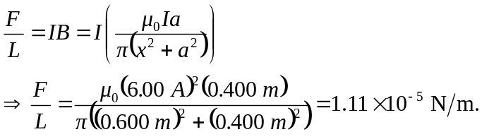

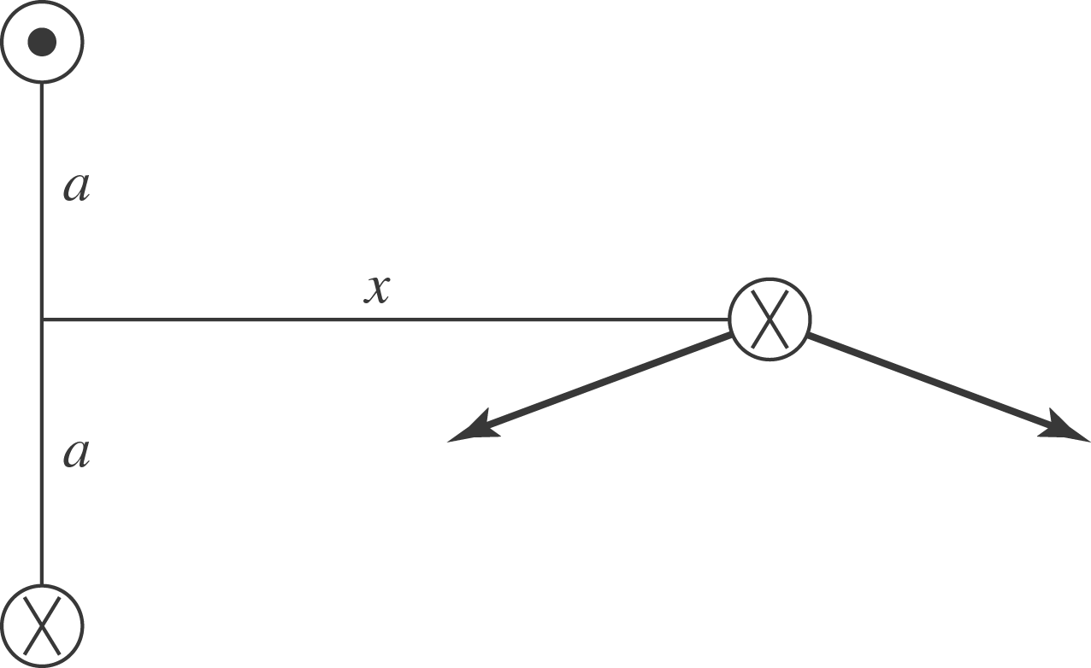

b) If the wire carries current out of the page then the forces felt will be the opposite of part (a) . Thus the force will be 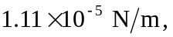 upward.

